This document should be used to assist the property in accessing and using the Lanyon Property Vault Website. All necessary steps and information requested per Wyndham International Corporate Office are outlined in this document and as follows to assist the user in this process.
- Each property is required to enter in all property information in their respective areas and enter in all and any applicable information in the visible categories.
- Each property is required to address every National Account that the hotel would submit a 2001 RFP for with regards to Rate Code and Rates - not just those accounts that the property has submitted a manual RFP.
- If a property will not be submitting any RFPs (e.g. Luxury Resorts), it is still required to access the website and complete all property and blackout date information..

ACCESSING THE LANYON PROPERTY VAULT WEBSITE:

STEP 1: | Access the Lanyon Property Vault Website in one of two ways:  - http://vault.Lanyon.com  - http://38.195.122.67

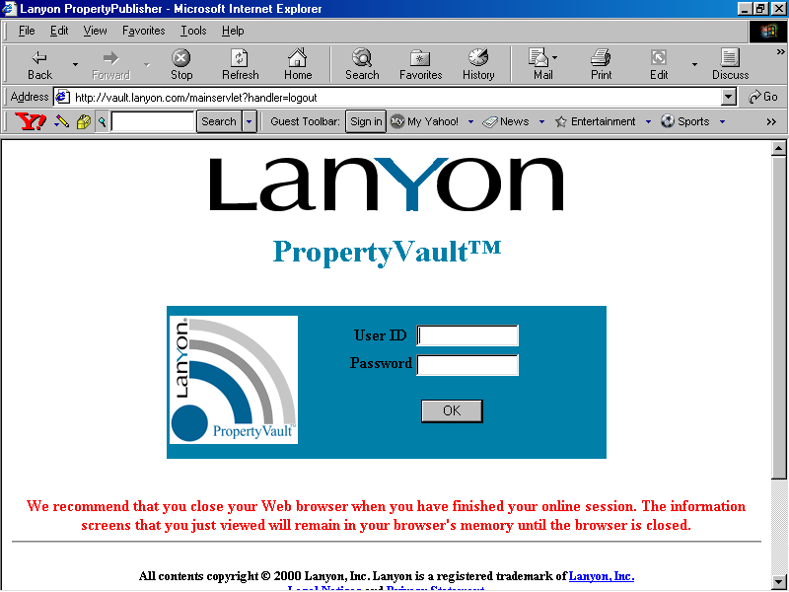

STEP 2: | Enter User ID and Password provided by your Corporate Representative then click OK.
STEP 3: | Once your Log In has been accepted you should now find yourself in the Property Vault Home Page. From this home page, you will have access to two areas:  - MESSAGING (the default screen – see example 2.0)  - PROPERTY PORTFOLIO

LANYON MESSAGING

This messaging system is designed to communicate any information regarding the RFP process. This includes deadlines set by the Corporate Office, upcoming RFPs, and any additional information that the National Sales Offices requires for National Account RFPs.

Note: It is imperative that each property log into the Lanyon Property Vault website every day and check repeatedly for messages from the Corporate Office. An audit system has been designed to track those properties not reading their messages.

Example 2.0:
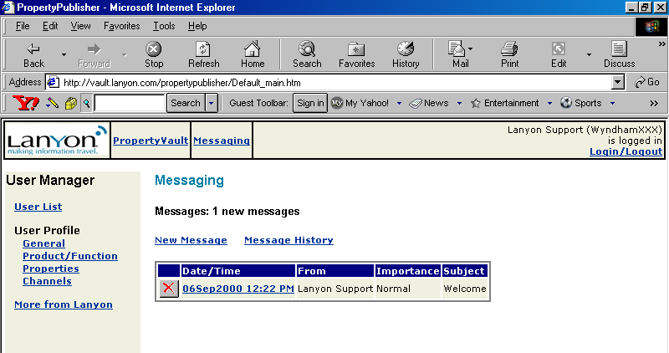

SENDING A MESSAGE:

STEP 1: | If you are not in Messaging, please click on Messaging at this time.
STEP 2: | Click on the New Message link that will bring you into a blank e-mail message screen.
STEP 3: | Using the “To:” drop down box, select the property or individual you would like to send a message to.  Note: At this time, this messaging system does not allow multiple recipients.
STEP 4: | Type your Subject and Message and when complete, click on the SEND MESSAGE button.

KEY REMINDERS
- This messaging system is solely for sending messages regarding the RFP process not to replace Microsoft Outlook.
- In order to ensure that you are receiving any new messages, it will be necessary to “refresh” your screen (click in another area and return back to Messaging).

PROPERTY PORTFOLIO

This will allow you to access your property’s detail information. You will be required to enter in any and all applicable information in each visible category (Blackouts, Profile, Rooms, Room Amenities, Rate Periods, Rate Plans, and Rate – General).

ACCESSING YOUR PROPERTY:

STEP 1: | If you are not in Property Portfolio, please click on Property Portfolio at this time.
STEP 2: | In the Display Properties screen, click on the SUBMIT button to view a list with your hotel along with the company’s “test” property. (see example 3.0)  Note: The “test” property can be used as a reference when completing this process.
STEP 3: | To access your hotel portfolio, click on your Hotel Name under the Property Name column. This will bring you to the Status Page - which you will need to access as you update your hotel’s progress in completing the RFP process.

Example 3.0
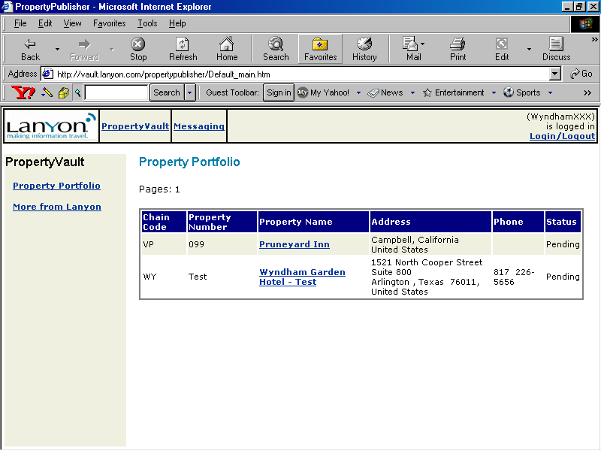

PROPERTY CATEGORIES:

All basic property information must be entered and updated as needed. This section will show a property’s blackout dates (if any), address and phone information, and the guestroom types to be extended along with their amenities.

BLACKOUTS:

The blackout dates listed are the dates you define for the agency/consortia program.

STEP 1: | If you are not in Blackouts, click on the Blackouts link at this time on the left menu area under Property Categories.
STEP 2: | Enter your property’s blackout dates. If there are more than 30 dates to list, please remember to rank in order of priority given that some companies restrict to top 30. (see example 4.0)  Note: If you are unable to access/edit the blackout dates, please contact your Corporate Representive via the Lanyon Messaging System.  If you have made any changes to your blackout dates that were previously submitted prior to this project, you must send Stacey Reames a Lanyon Message informing her of the change.

Example 4.0
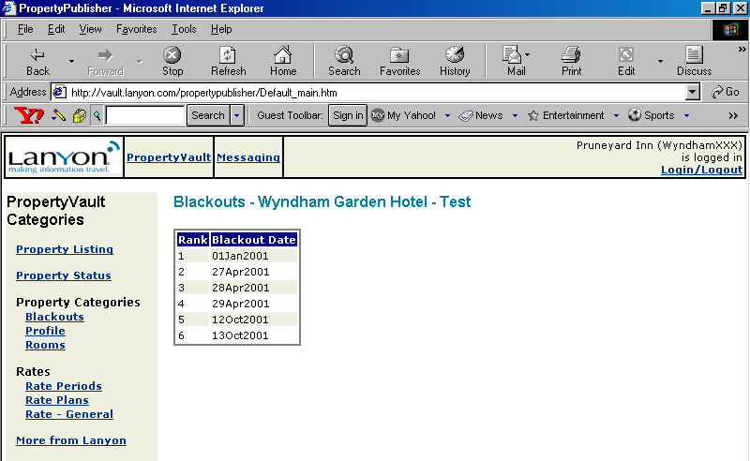

PROFILE:

This is the section where each property will provide their hotel information.

STEP 1: | If you are not in Profile, click on the Profile link at this time on the left menu area under Blackouts.
STEP 2: | Review all fields and ensure accuracy and update as necessary. If changes are made you must click on the SAVE CHANGES button. (see example 5.0)  Note: Our Phone Country = 01

Example 5.0
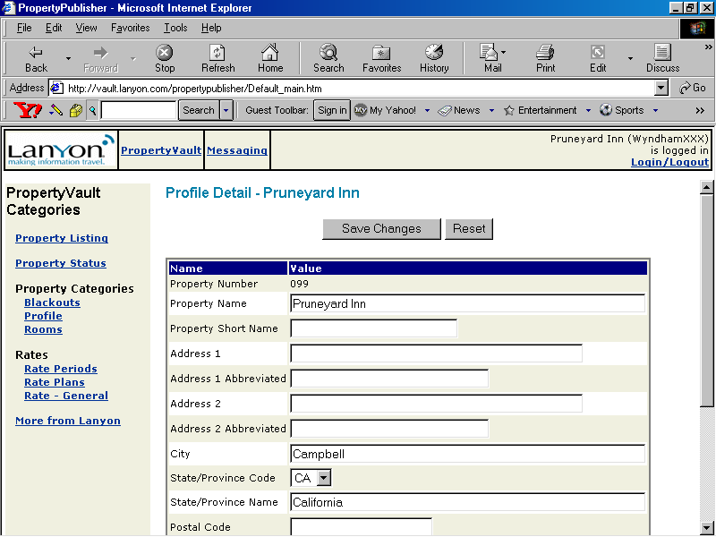

Note: At the bottom of the Profile Detail page there exists a HOTEL STATUS field which will need to be updated upon completion of all areas in the Lanyon Property Vault. When “Completed” is selected this will indicate to Corporate Office that all information is complete and accurate to the best of the property’s knowledge (see Example 6.0).

Example 6.0
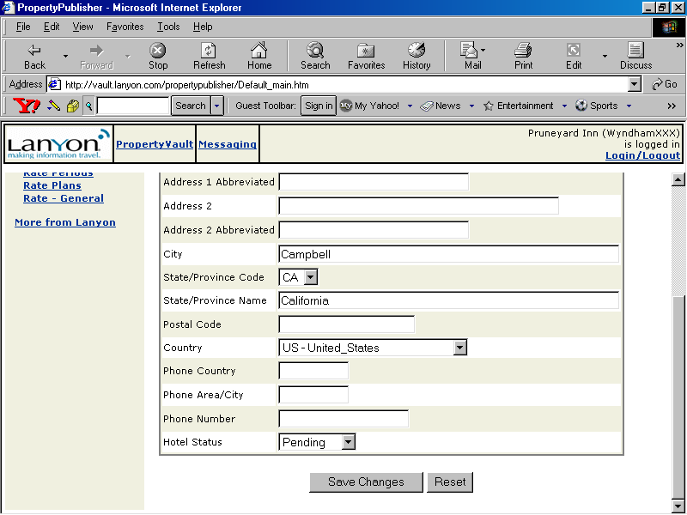

ROOMS:

In this section, the property will select the room types offered at the hotel. It is mandatory, at minimum; that the Standard room type is selected and the necessary information completed.

STEP 1: | If you are not in Rooms, click on the Rooms link at this time on the left menu area under Profile.
STEP 2: | Select Standard Room Type. This will be the largest inventory room type at the hotel.  Note: Placing a value in any of the fields to the right,, in effect selects the room type. If a value is placed and later deleted or zeroed out, currently the system registers it as selected and it will remain throughout the system as one of the selected room types.  Summerfield Suites Properties - use the following guidelines:  - 1-Bed Suite = Standard  - 2-Bed Suite = Deluxe  - 3 – Bed Suite = :Luxury (# of Beds = 1 King + 1 Double Double)
STEP 3: | Enter Capacity Per Room. This is the # of persons in the room not inventory of room type.
STEP 4: | Enter Number of Beds.
STEP 5: | Enter Description. The hotel may use the standard ISIS description provided by the hotel for this room type. (There is only 3 lines for this description).
STEP 6: | Repeat Steps 3-5 for any other additional room types your hotel is offering.
STEP 7: | Upon completion, click SAVE CHANGES button to ensure that all information has been updated in the system (see example 7.0).
Note: If you have approved ROH (Run of House) room types for your National Accounts, then you may select ROH as one of your selected room types.

Example 7.0
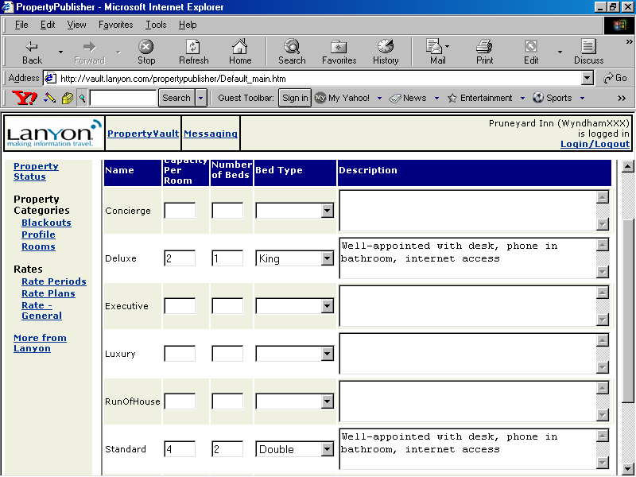

ROOM AMENITIES:

In this section, the property will select the different amenities provided by each room type selected.

STEP 1: | If you are not in Room Amenities, click on the Room Amenities link at this time on the left menu area under Rooms (see examples 8.0).
STEP 2: | Select the Standard room type.
STEP 3: | Select all amenities provided by this room type.
STEP 4: | Repeat Step 3 for all other room types hotel selected.

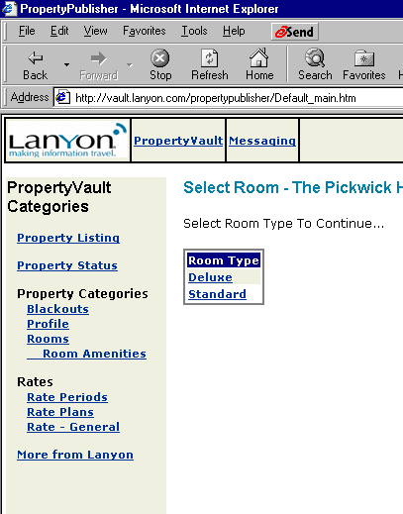
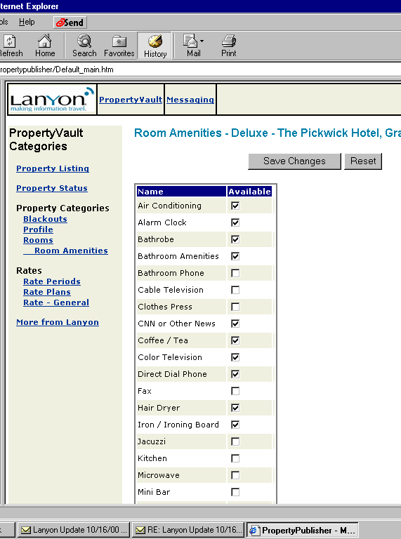
Example 8.0

RATES:

All rate information must be entered and updated as needed. This section will show a property’s rate periods for the current RFP season, the National Accounts and Rate Plans selected and rate values generally offered by the hotel.

RATE PERIODS:

The seasons reflected in this area, were defined by the property for the agency/consortia program. This one rate period plan will be used with all National Accounts the property chooses to submit a bid for.

STEP 1: | If you are not in Rate Periods, click on the Rate Periods link at this time on the left menu area under Rates.
STEP 2: | Click on 2001 to review the season defined for your property (see example 9.0).  Note: If your property is extending Midweek and Weekend rates for AAA or AARP, then it will be necessary to create a new season. Example 2001 – Midweek vs. 2001- Weekend.  In addition, if any National Accounts request multiple years, you will need to create 2001 Rate Period. If changes are necessary contact your Corporate Representative.

Example 9.0
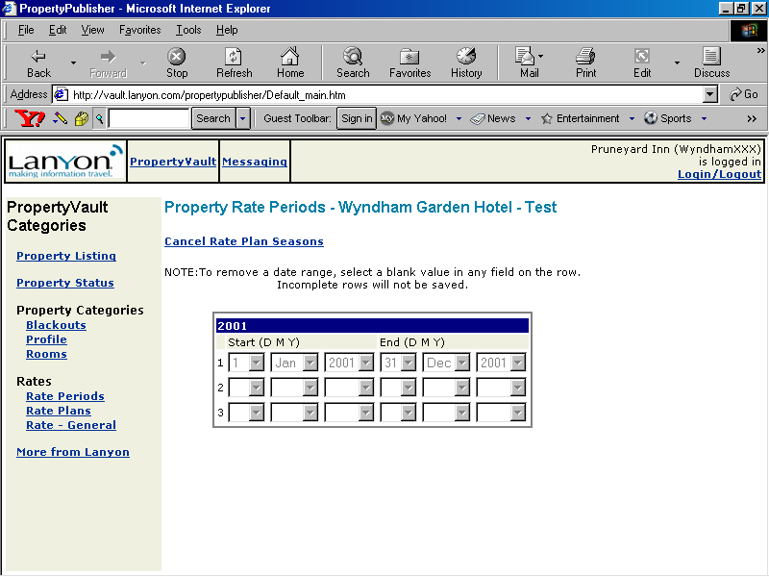

RATE PLANS:

There are approximately 150 rate plans set up for each property where negotiated rates can be defined. This list is reflected alphabetically. Defining the plan and rates for each National Account is a multi-step process so it is important that you review the following steps and complete accordingly to ensure accuracy and full completion of this Rate Plan section.

RATE PLAN
STEP 1: | If you are not in Rate Plans, click on the Rate Plans link at this time on the left menu area under Rate Periods.
STEP 2: | Click on the National Account under Rate Plan Name your hotel has submitted or would submit an RFP for (see example 10.0).  Note: If a National Account has requested rates for multiple years, you should have created a Rate Period for the subsequent years. Then, here you will create an additional Rate Plan for those Rates for Different Years.  Example: IBM-2001 vs. IBM-2002
STEP 3:  This field has been removed! | Rate Code. Enter the 2001 Standard National Account Rate Code located on your Rate Loading Worksheet.  Wyndham Policy:  - Rate Code = 3-Letter Designator for the National Account. Example: AAA  - There are no rate codes for the generic rate plans such as Consortia Net, Consortia Preferred, Government, Corporate, etc. at this time. The Revenue Team is creating these rate codes and will deliver upon completion. It is MANDATORY to complete the rate plan and rates for these plans; you will simply not have a Rate Code at this time.
STEP 4: | Rate Level. Leave blank at this time.
STEP 5: | Tax/Service Charge. Indicate if tax and/or service charge is included in the rate by placing a checkmark in the boxes provided.
STEP 6:This field has been removed! | Parity Rate Plan. Leave blank at this time.
STEP 6:  This field has been removed | Negotiated Rate Plan. This is the default selection that defines rate.  Wyndham Policy:  Negotiated Rate Plan = Non-Commissionable Rate. If this rate is commissionable, then remove the check from Negotiated Rate Plan and place a check in the Commissionable box below Advance Booking.
STEP 7: | Last Room Availability. Place a checkmark if the National Account will be offered last room availability.
STEP 8: | Advance Booking. Do not select this at this time.
STEP 9: | Commissionable and Commission Percentage. If this rate is commissionable, then place a checkmark in box provided and enter the applicable percentage.
STEP 10: | Length of Stay. Indicate the Minimum Length of Stay.  Wyndham Policy: At least 1 Day Minimum.  Summerfield Suites:  If you offer rates to a corporation based on length of stay, it will be necessary to create additional rate plans to submit the different rates – See Extended Stay Rate Plan Instructions (example 12.0).
STEP 11: | Cancellation Period. Select the appropriate cancellation period.

STEP 13: | Place a checkmark on all the Room Types this rate plan applies.  Note: Standard room type is mandatory and should be remain checked by default.
STEP 14: | Select the Season(s).
STEP 15: | Upon completion, click on the SAVE CHANGES button to update and exit back to the list of Rate Plans (National Accounts).

Example 10.0
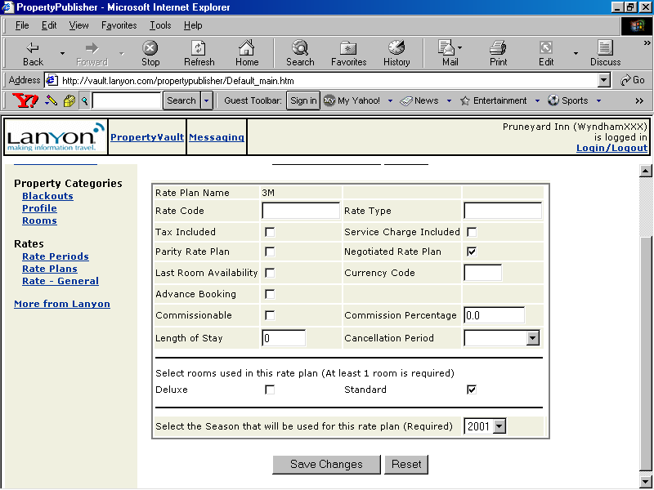

RATES
STEP 16: | To enter Rates, click on View Rates for the Rate Plan currently working on.  Note: There must be rates for both Single and Double Occupancy, even if offering a Flat Rate.
STEP 17: | In Rate Details, you should see the Room Type(s) selected for this plan. Enter all applicable rates that will be extended (see example 11.0)
STEP 18: | Upon completion, click on the SAVE CHANGES button to update and exit.
STEP 19: | Repeat Steps 2-18 for all applicable Rate Plans (National Accounts).

Example 11.0
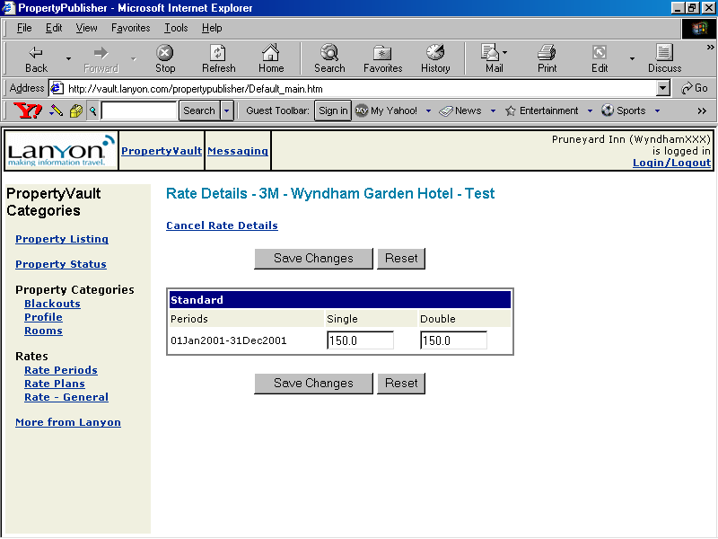

Example 12.0
EXTENDED STAY RATE PLAN INSTRUCTIONS
STEP 1: | Under the Hotel Rate Plans screen, click on the NEW button.
STEP 2: | In the Rate Plan Detail screen (see example 10.0), type the Rate Plan name followed by –b, -c, etc. depending on how many stay restriction plans have been created.  - 3M = 1 Day Minimum Length of Stay  - 3M-b = 5 Day Minimum Length of Stay  - 3M-c = 30 Day Minimum Length of Stay  - 3M-d = 30+ Day Minimum Length of Stay
STEP 3: | Follow the same process as outlined in completing Rate Plans and Rates
STEP 4: | Repeat Steps 1-3 for as many Extended Stay Plans the property defines.

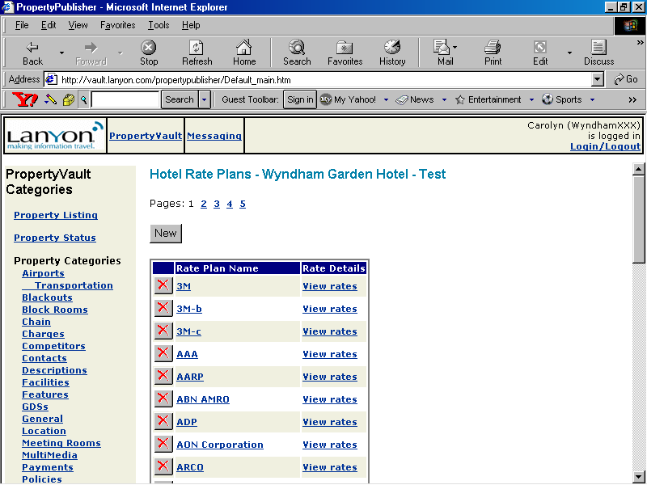

RATE – GENERAL:

This category covers additional general rate information such as room type guarantees through CRS, GDS, and property, and rate loading instructions. Information completed in this category will apply to all rates loaded in your property portfolio.

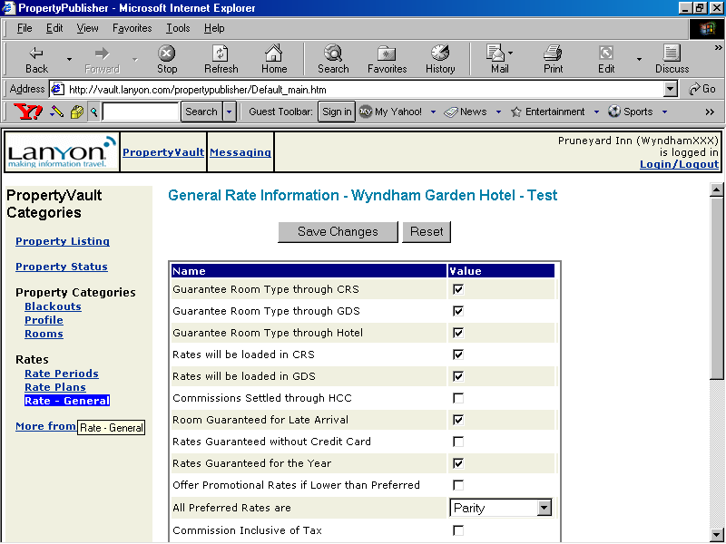

Note: This information is what you would normally see on your NBTA form and is unique to your hotel. Select the value if it pertains to 50% or more of the National Accounts. If there is any doubt, do not select the value.

Once the property has determined that all categories defined within the Property Vault has been addressed and all National Account Rate Plans have been completed, it must return to the Profile Property Category to change the Hotel Status to “Complete”. In addition, under Property Status, all defined areas must also be changed to “Complete” because this will indicate Corporate Office of total completion.

LANYON PROPERTY VAULT FAQs:
Category | Question/Concern | Response
Blackout | Does my blackout dates need to be in chronological order? What if I have more than 30? | No. If you have more than 30 dates, please make sure you rank in order of priority since most companies max out blackout periods up to 30.
Rate General | What does HCC stand for? | Commission-Clearing House. We are using Pegasus now for this so that name will change.
Rate General | What values should I select if it differs for some companies? | Select items as a value if it applies to 50% or more of the companies you are submitting RFPs for. Ultimately, if you are not comfortable, do not select the item.
Rate Plans | If we are not submitting rates for an RFP do we delete with the red X? | You cannot delete this. This is to delete the corporate account and we do not want to do this at this time.
Rate Plans | Dow we need to add all of the corporate negotiated, discounts, internet rates, etc. or just respond to the listing in Lanyon? | Just respond to the listing in Lanyon
Rate Plans | What is “Rate Type”? | Leave blank at this time.
Rate Plans | What is “Advance Booking”? | Do not select at this time.
Rate Plans | What do I enter for “Length of Stay”? | Wyndham Standard is “1”. Please note that Summerfield Suites may have tiered Minimum Length of Stays.
Rate Plans | As we work on the Rate-Loading Project, we notice that not all accounts are listed. | This is the most current list Lanyon has at the moment. This will be updated as we move forward with the BETA Project. Just complete for accounts listed at this time.
Rate Plans | If it is a net parity rate (non-commissionable), what do we mark – parity rate plan or negotiated rate plan? | Negotiated Rate Plan
Rate Plans | What rates am I loading for? | 2001

LANYON PROPERTY VAULT FAQs (continued):
Category | Question/Concern | Response
Rate Plans | If a property has rejected a program/rate plan, do they have to enter it or just those that they are participating in? How will the system know that we are not participating at this time? | Right now they need to leave the rate blank and in the participating column the view will be “No”.
Rate Periods | What if I have Midweek or Weekend Rates? | You will need to create new season to reflect those rates separately.
Rooms | I would like to put more information in the room description that what they have in ISIS. Does this Lanyon Room Description have to match ISIS? | No. This is simply a guideline to follow if properties are unsure of what to enter in the description area.
Rooms | Where do I enter the inventory of each room type? | There is no place in Lanyon at this time to enter that information.
N/A | What if my hotel does not participate in Transient National Accounts? Do I need to enter property information into Lanyon? | Yes. Even if your hotel is not bidding on any national accounts. You still need to complete all Property Detail information and, possibly, Blackout Periods. Make sure to inform your Regional Lanyon Corporate Representative so they are aware of why there may be blank information in some categories.
N/A | Where can we add concessions granted to specific companies for their business (e.g. free phone calls, breakfast discounts, etc.)? | There is no area at this time. We are looking into an “Additional Questions” section for the future.
N/A | Now which categories are required to be filled out? | Blackouts, Profile, Rooms, Room Amenities, Rate Periods, Rate Plans and Rate General

